Occupational SURVEY 2023-2024

Today’s Date_________________ District_______________________ Grade level______________________

1. Have you moved within the last 3 years?
Yes No
2. If yes, have you done agricultural or fishing related work since your move? (e.g., field work, canneries, lumbering, dairy work, meat processing, sheep shearing, working with cotton, pecans, grapes, wheat)
Yes No

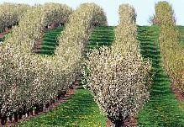
If you answered “yes” to both of the questions above, an education representative may contact you to find out whether your child is eligible for additional educational services such as:
· free breakfast and lunch
· school supplies
· parent and student training
· early childhood literacy program
· leadership programs for secondary students

Please provide the following information:
Name of child: D.O.B.: Age:
Parent/Guardian Name:
Telephone Number:
Best Time to Contact You:_____________________________________________________________

